Health and Safety

Policy

Date | Revisions & Updates | Page No. | Approval
Jan 2022 | New Policy created | Inclusive | N. Bird

Scope

This policy applies to all staff, students, contractors and visitors within AccXel, the live site or at other locations including off-site activities.

Purpose

To ensure that all AccXel activities are carried out in a safe and healthy manner, in a safe and healthy environment, in accordance with the Health & Safety at Work Act 1974, and the Health & Safety (Management) Regulations 1999.

Comment

Health & Safety codes of practice and safe systems of work for subject areas are considered an extension of this policy and should be reviewed on an annual basis. Health & Safety is the responsibility of everyone and should be proactive rather than reactive.

Statement of Policy

AccXel recognises and accepts its responsibility as an employer and education provider for providing a safe and healthy workplace and learning environment for all employees, learners and the public and will take all steps to meet this responsibility, paying particular attention to the provision and maintenance of:
- Plant, equipment, and systems of work that are safe and without risks to health
- Safe systems of work in the use, handling, storage and transport of articles and substances
- Sufficient information, instruction, training, and supervision to enable all employees and learners to avoid hazards and to contribute positively to their own safety and health at work
- A safe place to work with safe means of access and egress
- A safe and healthy working environment with adequate welfare facilities.

AccXel will seek to ensure that learning takes place in a safe, healthy and supportive environment which meets the needs of learners. Where part of the learning takes place outside AccXel, AccXel will assess the health & safety suitability and risk assess the activities as necessary.

The AccXel Senior Management Team are responsible for ensuring safe conditions of work in the areas under their control. Competent technical advice on health and safety matters will be provided by a competent health & safety professional. AccXel recognises and accepts its responsibilities in respect of persons not in their employment (e.g., visitors, learners, contractors) who may be exposed to risks to their health and safety as a result of the activities of AccXel.

The policy statement will be reviewed annually or modified as necessary when updates or changes occur.

This statement is to be displayed in a prominent position at AccXel. A full copy of the company’s health & safety policy with full details of the organisation and arrangements for implementing the policy will also be available at each work location, for reference on request.

All employees and particularly those with supervisory responsibilities must recognise the need for and accept responsibility for safe systems of work. The adequate delegation of these responsibilities in case of absence from work must be ensured. It is the responsibility of everyone to help to make this safety policy work and assist in maintaining a safe and healthy working environment for all.
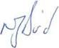

Signed: Date: June 2021
06/01/2022
Nicola Bird Reviewed
Managing Director

Organisation

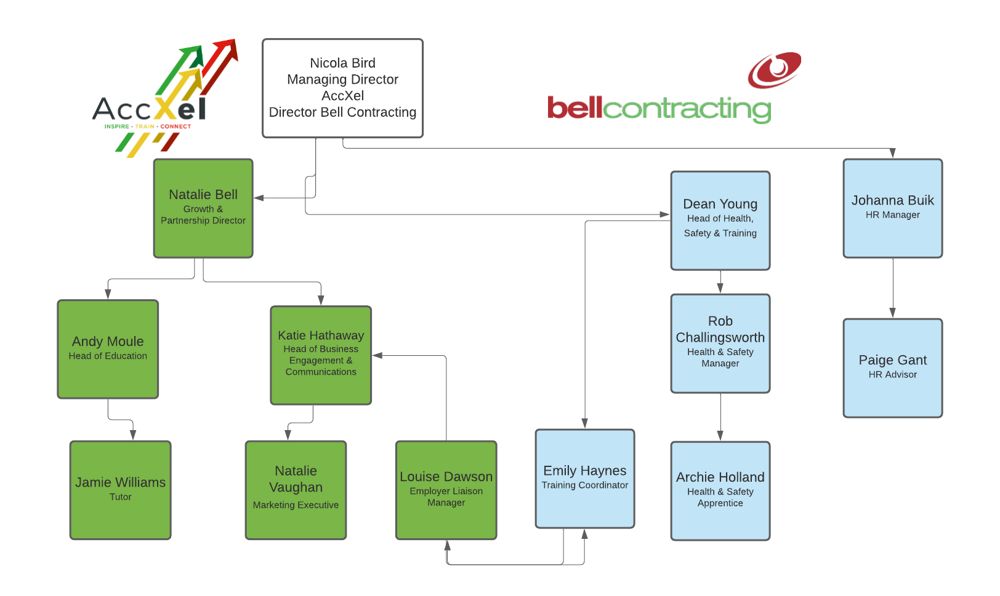

The Duties of the Parent Company (Bell Contracting Ltd)
- To ensure that this policy is implemented and kept under review.
- To ensure that the statutory requirements are observed, and that relevant records and reports are in order.
- To receive reports and monitor actions or concerns relating to the effectiveness of AccXel’s Health and Safety Policies and Procedures to ensure that a safe and healthy environment is maintained for staff, learners and the public. This will be carried out by a competent health and safety professional.

The Duties of the Managing Director
- To have overall responsibility for the Health and Safety Policy and its implementation.
- To ensure responsibilities for Health & Safety Policy are properly assigned and accepted at all levels.

The Duties of the Senior Management Team
- To ensure that this policy is implemented and kept under review.
- To ensure that employees are aware of their responsibilities under the policy and comply with the safety procedures of the AccXel.
- To ensure periodic safety inspections are carried out.
- To ensure that defects in premises, plant and equipment are reported promptly through the normal systems operating in AccXel.
- To ensure that all accidents are recorded and reported as necessary, to the appropriate authorities.
- To ensure that all accidents are investigated, and appropriate steps taken to prevent recurrence.
- To seek co-operation from all employees in order to create a safe environment and the elimination or reduction of potential risks.
- To ensure that facilities provided for the public are adequate as far as safety is concerned and that the work carried out by employees does not adversely affect the Safety or Health of the public.

The Duties of all Team Leaders and Teaching Staff.
- To ensure that staff under their control implement safe working practices.

- To ensure as part of the AccXel induction, that new staff, especially contracted or part time are competent in their respective vocational areas and are familiar with AccXel procedures.
- To ensure the adequate provision of protective clothing and equipment, where necessary, for staff, learners and visitors to areas under their control.
- To establish procedures for identifying hazards and assessing risks within areas under their control, and as far as is reasonably practicable, reduce or eliminate those risks.
- To ensure that learning environments outside the AccXel are assessed for Health & Safety suitability prior to learners being placed in that environment and are monitored at appropriate intervals thereafter.
- To ensure that staff involved in the production or maintenance of Health and Safety records keep such records up to date and available for inspection by an authorised person.

The Duties of the AccXel Health and Safety Officer (Bell Contracting Ltd)
- Visiting AccXel on a regular basis to evaluate safety management performance.
- Ensuring all new staff regardless of the type of contract, undertake the appropriate health and safety induction and records are maintained by HR
- To ensure that statutory requirements regarding Health & Safety are met.
- Ensuring that all risk assessments are comprehensive and fit for purpose. Monitor and review Risk Assessments and processes as required.
- Leading and advising on the investigation of incidents, accidents or ill health involving employees or learners/students.
- To organise and check the effectiveness of evacuation procedures.
- To monitor, evaluate and follow up accident reports with appropriate action to prevent recurrence.
- To liaise with external agencies e.g., Local Authority, ESFA, Fire Brigade, HSE, regarding AccXel Policy and practice in respect of Health and Safety issues.
- To liaise with the HR department regarding training programmes for staff in respect of Health and Safety.

- To carry out Periodic Inspections and Health & Safety audits of Curriculum areas with Curriculum Managers.

The Duties of Students
- Be aware of, and abide by, all AccXel procedures and safe systems of work.
- Wear and use appropriately any personal protective equipment provided by AccXel or their employer and report any defects and arrange a replacement promptly.
- Report to a member of staff any danger identified.
- Report to any lecturer/assessor any accident they have been involved in both at AccXel, including on the live site.
- Not misuse or interfere with any equipment provided for health, safety, and welfare.
- Not enter any area or use any equipment unless they have been authorised and trained to do so.

The Duties of all Employees
- To comply with the Health and Safety Policy of AccXel.
- To take reasonable care for the health and safety of themselves and of other persons who may be affected by their acts or omissions.
- To observe the laid down systems of safe working and to take any precautions necessary.
- To use the correct tools and equipment for the job and to ensure that they are kept in good condition and not adapted for inappropriate use.
- To make use of safety aids, appliances, equipment and protective clothing where necessary.
- Not to interfere with or misuse anything provided in the interests of health, safety and welfare.
- To report immediately to their line manager any unsafe conditions or defects in plant and equipment. In accordance with Regulation 8 of the Management of Health and Safety at Work Regulations 1999, all staff should take reasonable steps to remove themselves from the immediate place of danger (such as a dangerous workshop or classroom) and to a reasonable place of safety. Places of safety include atriums, communal areas and fire evacuation points.
- To report immediately any accident that occurs. Where a piece of plant or equipment is involved it must not be interfered with, and action must be taken for its removal from use and secure retention pending investigation of the accident.
- To understand the emergency procedures.
- To co-operate with the management and Board to enable them to carry out their duties under the Health and Safety at Work Act 1974 and associated legislation.
- To seek advice from the Senior Management Team.

Arrangements

Management of Health and Safety
  - General risk assessments for AccXel are reviewed when any significant changes to AccXel operations take place and, in any case, annually and revised as necessary in order to meet the requirements of Regulation 3 of the Management of Health & Safety at Work Regulations 1999.
  - More detailed risk assessments covering specific areas of AccXel operations and special events are carried out, reviewed and revised as necessary, and in any case annually.
  - The AccXel Head of Safety is the competent person to advise the AccXel Management of the measures they need to take to comply with the requirements placed upon them by relevant health and safety regulations, in accordance with regulation 7 and 8 of the Management of Health & Safety at Work Regulations 1999.
  - Monthly safety inspections are carried out in all areas of AccXel. The inspections are forwarded to the relevant manager so that any remedial action necessary can be promptly undertaken. Completed inspections are completed in a digital format on a share cloud drive.
  - Internal Health & Safety audits are carried out, covering all areas of AccXel operations annually.
  - Risk Assessment is embedded into the lesson planning process and an assessment of the health & Safety aspects of lessons are an integral part of the lesson observations.
  - Arrangements for the management of Health & Safety are audited on a regular basis by the AccXel Auditors and by Insurers.
  - Health & Safety considerations are central to the Staff Development programme. AccXel staff are supported and encouraged to undertake any training needed to carry out their duties safely or for personal development.
  - Health & Safety forms an integral part of the AccXel’s Risk Management Strategy.
  - Health and Safety matters arising are discussed every month at the AccXel Management meetings.

Information, Instruction, Training, Supervision
  - The Health & Safety Law poster is displayed within the staff room.
  - Health & Safety advice is available from:
Bell Contracting Ltd. Whimsey Industrial Estate, Cinderford. 01594824482
  - Supervision of young workers or trainees will be arranged by the managers in whose area the trainees are placed.
    - All new staff are given Health & Safety training as part of the induction process administered by Human Resources. This will involve general matters such as first aid provision and emergency evacuation procedures and also job specific training to enable the staff member to carry out their duties safely.
    - All staff participate in the AccXel Performance Appraisal review process and annual Performance Appraisal reviews will identify ongoing Health & Safety training and refresher training requirements.

Plant and Equipment
  - Lifting Equipment
All lifting equipment is tested and examined by independent insurance engineers in accordance with the Lifting Operations and Lifting Equipment Regulations 1998.

Portable Electrical Appliances
All portable electrical appliances will be inspected and tested in accordance with HSE Guidance.
Equipment that has been checked and passed will be identified by a dated sticker and recorded in the PAT register. Appliances failing the tests will be made inoperable, isolated from the electricity supply and the relevant manager will be informed.
Unauthorised electrical equipment should not be brought onto AccXel premises.

Transport
  - All vehicles are checked daily by user drivers in accordance with guidelines issued by the Traffic Commission.

Control of Substances Hazardous to Health
  - The Control of Substances Hazardous to Health Regulations 2002 require AccXel as an employer to:
    - Assess the risk to health and the precautions needed to protect health from substances used, stored or transported within the AccXel.
    - Implement appropriate measure to control any risk.
    - Monitor the exposure of employees where necessary.
    - Inform, instruct and train employees about the risks and the necessary control measures.
  - In order to achieve compliance with the above, relevant Managers are asked to:
    - Read the literature provided regarding COSHH.
    - Discuss this with the staff in your department.
    - Identify any substances which may be hazardous to health, and with the help of their technical staff and the AccXel’s Head of Safety if necessary, carry out a COSHH Assessment and keep a record of it on the standard form provided.
    - Inform staff and learners of any risks identified and the control measures to be taken.
    - Review, update and sign the assessment at least annually.

Fire
  - In accordance with the Regulatory Reform (Fire Safety) Order 2005, fire risk assessments have been carried out at all main AccXel centres in order to ensure that the AccXel complies with the requirements of the Fire Regulations.
  - AccXel is fitted with automatic fire detection and alarm systems linked to both smoke and heat detectors.
  - All AccXel fire alarm systems are tested and maintained by an external specialist company.

Assembly Areas:

Are shown on inductions and are displayed within the entrance of AccXel.

Fire Drills:
A fire drill will be carried out once per quarter. Any issues relating from fire drills will be reported to the AccXel Head of Safety.

Fire Precautions
  - Housekeeping
Combustible material must not be stored in boiler houses, stairwells, protected corridors etc. Fires commence and spread more easily in congested places and their progress is accelerated by rubbish, waste and dust.

Petrol etc
Petroleum based products exceeding 15 litres in quantity should not be stored inside AccXel buildings, including within the live site.
Such substances should be stored in steel storage bins with close fitting lids.

Fire Extinguishers
If a fire extinguisher has been used, accidentally or otherwise, the AccXel Head of Safety should be notified as soon as possible so that the extinguisher can be recharged. This also applies to any other fire-fighting appliances that require attention.

Fire Alarms
At no time should fire alarms be rendered inoperable. Alarms will be tested weekly.

Accidents, ill-Health and First Aid:
  - Sufficient first aiders trained to ‘First Aid at Work’ standard will be provided at AccXel in accordance with the requirements of the Health & Safety (First Aid) Regulations 1982, taking into account the numbers of people at each centre and the types of activity undertaken.
Names of first aiders and their telephone numbers are available on the inside of the entrance of AccXel. First Aid boxes are located on the ground floor of AccXel and on the live site.
All accidents at AccXel regardless how minor, must be reported immediately to AccXel Head of Safety.
Accident reports are protected under the Data Protection Act. As such, any completed reports must be kept confidential and only seen by those persons authorised to do so. In practice this means the old accident book has been replaced by an Accident Recording System which ensures compliance with these data protection requirements.

RIDDOR - The Reporting of Injuries, Diseases and Dangerous Occurrences Regulations 2013.
RIDDOR reportable accidents and dangerous occurrences must be reported to the HSE Reporting Centre by any of the following means:
www.hse.gov.riddor

Relating Documents
- Accident Forms
- Monthly Safety Inspection Records
- Risk Assessment Forms
- COSHH Assessment Forms
- Fire Risk Assessments
- IAuditor Reports
Related Policies & Procedures
- Fire (Emergency Evacuation) Procedure
- Accident and First Aid Procedure
- Employee Handbook
- Full Safe Systems of Work
- Full Suite of Methods Statements
- Full Suite of Risk Assessments

